Indexed File
# Source: AI Source: Provided by: [Data Path: Persons Table -> ID Column: 1, Name_En Column: Motasem Essam] -> From: [Chatgpt (GPT‑5 Mini)] on [1/26/2026]
An Indexed File is a type of file organization where an index is created to quickly locate records in the file.
👉 The index works like a book index: instead of searching the whole file, you look in the index to find where the record is stored, then jump directly to it.

Definition
# Source: AI Source: Provided by: [Data Path: Persons Table -> ID Column: 1, Name_En Column: Motasem Essam] -> From: [Chatgpt (GPT‑5 Mini)] on [1/26/2026]
An indexed file stores records along with a separate index table that contains:
- a key field (like ID number)
- the address/location of the record in the file

How It Works
# Source: AI Source: Provided by: [Data Path: Persons Table -> ID Column: 1, Name_En Column: Motasem Essam] -> From: [Chatgpt (GPT‑5 Mini)] on [1/26/2026]
- You search for a key value (e.g., StudentID = 102).
- The system checks the index.
- The index tells the exact position of the record.
- The system directly accesses the record.

Example
# Source: AI Source: Provided by: [Data Path: Persons Table -> ID Column: 1, Name_En Column: Motasem Essam] -> From: [Chatgpt (GPT‑5 Mini)] on [1/26/2026]
Data File
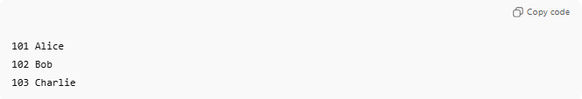
101 Alice
102 Bob
103 Charlie
Index File
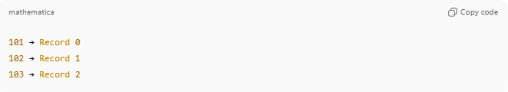
101 → Record 0
102 → Record 1
103 → Record 2
- To find Bob (102) → look up 102 in the index → jump to record 1.

Advantages
# Source: AI Source: Provided by: [Data Path: Persons Table -> ID Column: 1, Name_En Column: Motasem Essam] -> From: [Chatgpt (GPT‑5 Mini)] on [1/26/2026]
✔ Fast searching
✔ Direct access to records
✔ Efficient for large files

Disadvantages
# Source: AI Source: Provided by: [Data Path: Persons Table -> ID Column: 1, Name_En Column: Motasem Essam] -> From: [Chatgpt (GPT‑5 Mini)] on [1/26/2026]
❌ Extra storage needed for index
❌ Index must be updated when records change

Where Indexed Files Are Used
# Source: AI Source: Provided by: [Data Path: Persons Table -> ID Column: 1, Name_En Column: Motasem Essam] -> From: [Chatgpt (GPT‑5 Mini)] on [1/26/2026]
- Databases
- Library management systems
- Banking systems
- Student record systems

Comparison with Sequential File
# Source: AI Source: Provided by: [Data Path: Persons Table -> ID Column: 1, Name_En Column: Motasem Essam] -> From: [Chatgpt (GPT‑5 Mini)] on [1/26/2026]
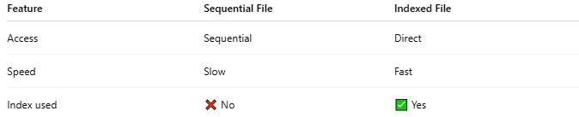
Feature | Sequential File | Indexed File
Access | Sequential | Direct
Speed | Slow | Fast
Index used | ❌ No | ✅ Yes

💡 Analogy:
# Source: AI Source: Provided by: [Data Path: Persons Table -> ID Column: 1, Name_En Column: Motasem Essam] -> From: [Chatgpt (GPT‑5 Mini)] on [1/26/2026]
- Sequential file → Read a book page by page
- Indexed file → Use the index to jump to the page you want

